Instructions for Alumni who do not already have a Myhub account created.

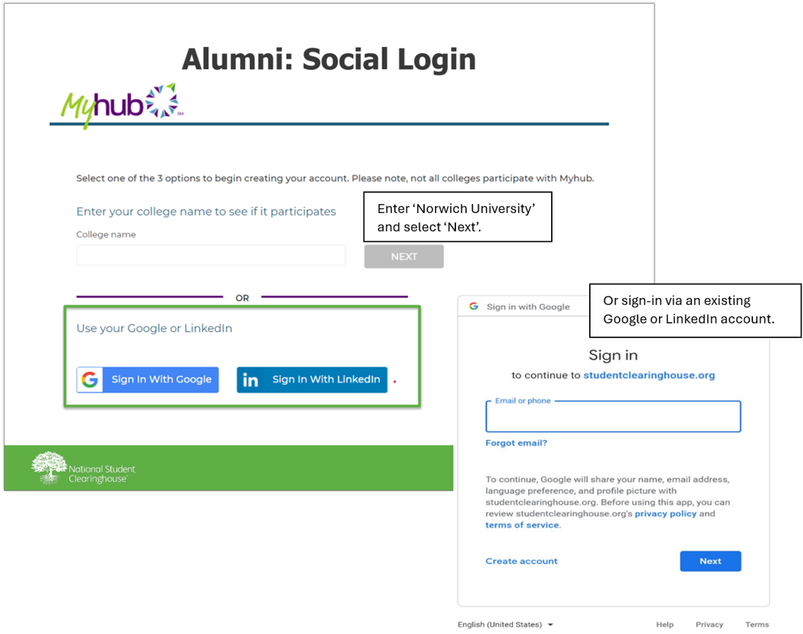

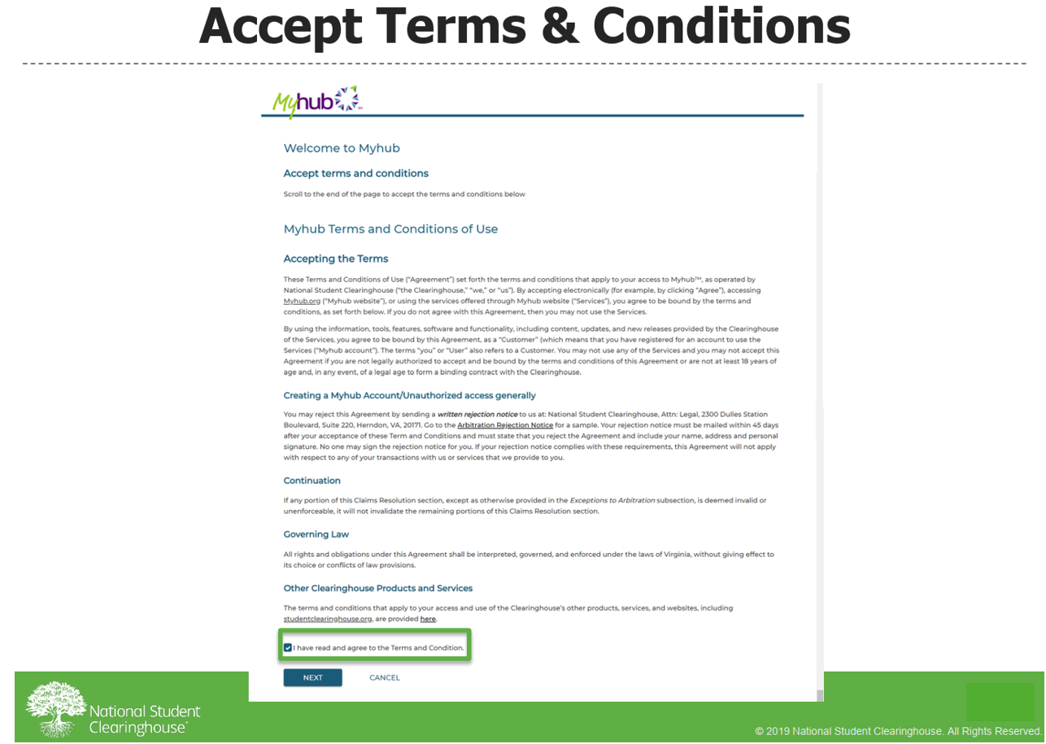
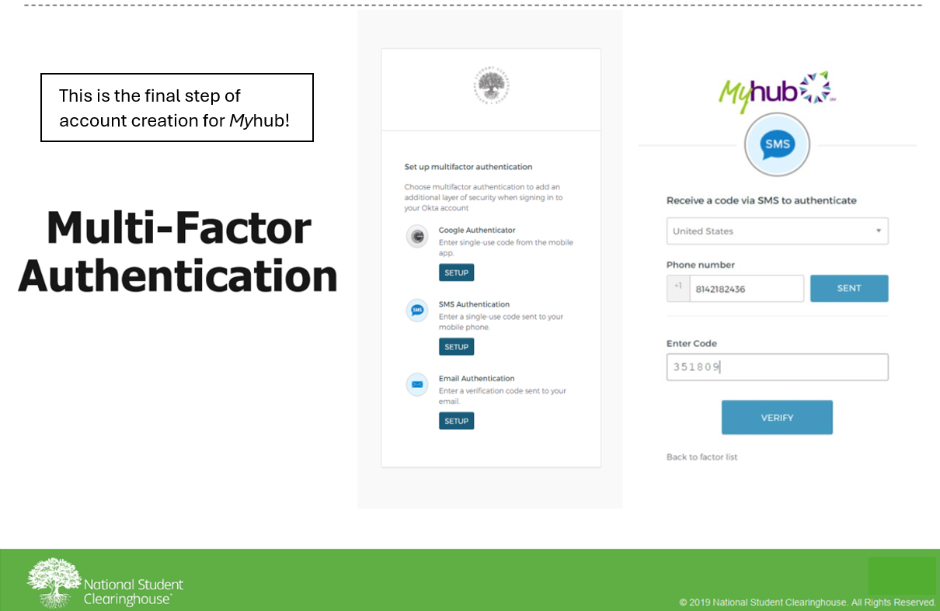
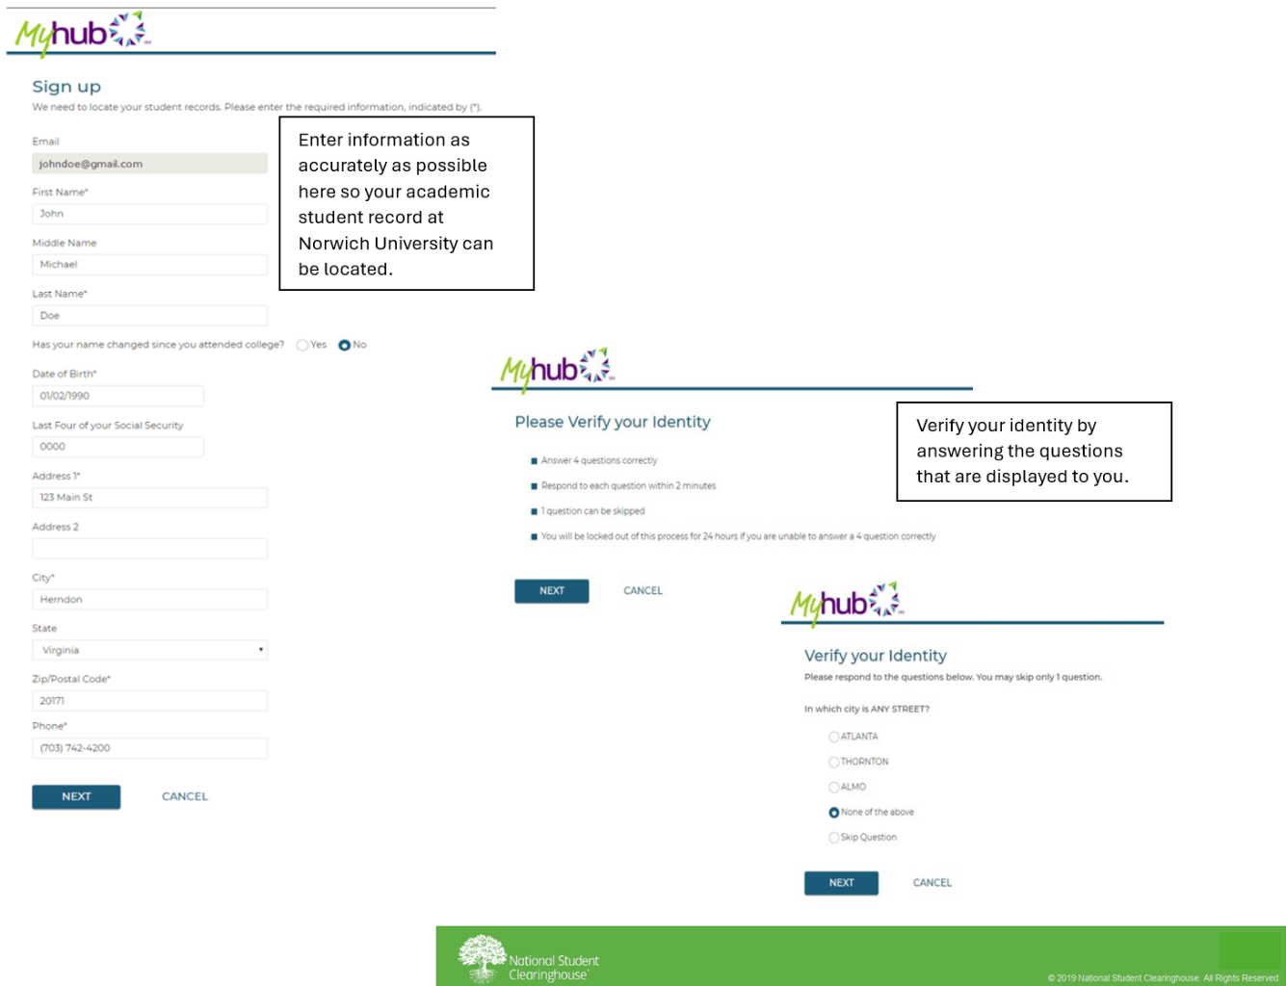
If your identity cannot be verified, you can try again.
After three unsuccessful attempts to verify your identity, your account may become locked. If this should occur, please contact the Registrar Office for assistance.

